Jake Sylvestre

Civil Rights Album Cover

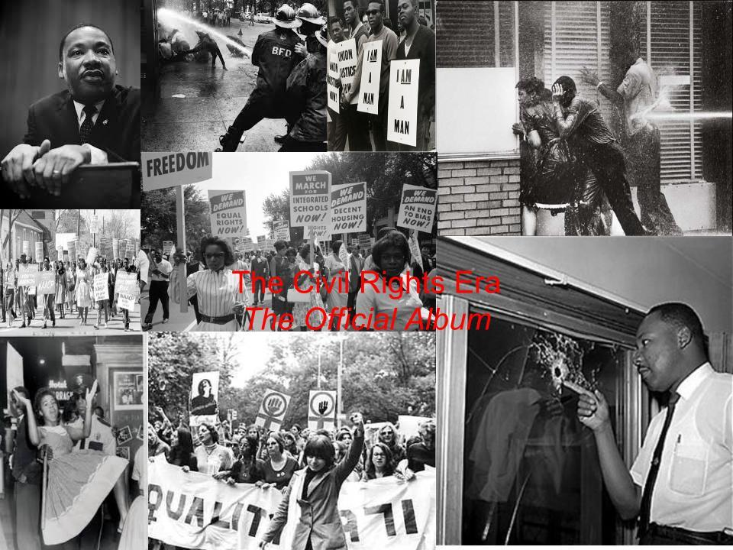

Jake Sylvestre

H History 1

Civil Rights Movement

Playlist Project- The death of Emmett Till Lyrics

’Twas down in Mississippi not so long ago

When a young boy from Chicago town stepped through a Southern door

This boy’s dreadful tragedy I can still remember well

The color of his skin was black and his name was Emmett Till

Some men they dragged him to a barn and there they beat him up

They said they had a reason, but I can’t remember what

They tortured him and did some things too evil to repeat

There were screaming sounds inside the barn, there was laughing sounds

out on the street

Then they rolled his body down a gulf amidst a bloody red rain

And they threw him in the waters wide to cease his screaming pain

The reason that they killed him there, and I’m sure it ain’t no lie

Was just for the fun of killin’ him and to watch him slowly die

And then to stop the United States of yelling for a trial

Two brothers they confessed that they had killed poor Emmett Till

But on the jury there were men who helped the brothers commit this

awful crime

And so this trial was a mockery, but nobody seemed to mind

I saw the morning papers but I could not bear to see

The smiling brothers walkin’ down the courthouse stairs

For the jury found them innocent and the brothers they went free

While Emmett’s body floats the foam of a Jim Crow southern sea

If you can’t speak out against this kind of thing, a crime that’s so unjust

Your eyes are filled with dead men’s dirt, your mind is filled with dust

Your arms and legs they must be in shackles and chains, and your blood

it must refuse to flow

For you let this human race fall down so God-awful low!

This song is just a reminder to remind your fellow man

That this kind of thing still lives today in that ghost-robed Ku Klux Klan

But if all of us folks that thinks alike, if we gave all we could give

We could make this great land of ours a greater place to live

Jake Sylvestre

H History 1

Civil Rights Movement

Playlist Project- The death of Emmett Till Analysis

Bob Dylan’s classic “*The Death of Emmett Till”* also known as “*The Ballad of Emmett Till*” tells the story of one notable instance of violence against blacks in the south. From the beginning of the song the artists puts an emphasis on the color of his skin as one of the motives for the murder. The artists then goes on to describe the crime in vividity, describing torture, and even the sound of his screams creating a deep sense of empathy for the victim. After this horrific description, the artists describes how nonchalantly they disposed of the body, as if he were nothing. He also describes two more motives, which make the murderers seem, and rightfully so, more evil by saying “was just for the fun of killin’ ” and “to watch him slowly die”. Bob Dylan then tells how even after their admission of guilt, they were found innocent because of biased co-conspirators on the jury. This line well demonstrates the avid corruption of the time. Next he puts much emphasis, through the use of a whole verse, on their smile as they left the courtroom. The next two verses, as well as the end of this song are call out to all men to stop racism and make this “land of ours a greater place to live”. I chose this song because of the message at the end, that if we stop racism, and just try a little harder we can make our land greater. It also highlights an important event of the civil rights era.

Jake Sylvestre

H History 1

Civil Rights Movement

Playlist Project- Only a pawn in their game Lyrics

A bullet from the back of a bush took Medgar Evers' blood

A finger fired the trigger to his name

A handle hid out in the dark

A hand set the spark

Two eyes took the aim

Behind a man's brain

But he can't be blamed

He's only a pawn in their game.

A South politician preaches to the poor white man

"You got more than blacks, don't complain

You're better than them, you been born with white skin" they explain

And the Negro's name

Is used it is plain

For the politician's gain

As he rises to fame

And the poor white remains

On the caboose of the train

But it ain't him to blame

He's only a pawn in their game.

The deputy sheriffs, the soldiers, the governors get paid

And the marshals and cops get the same

But the poor white man's used in the hands of them all like a tool

He's taught in his school

From the start by the rule

That the laws are with him

To protect his white skin

To keep up his hate

So he never thinks straight

'Bout the shape that he's in

But it ain't him to blame

He's only a pawn in their game.

From the powerty shacks, he looks from the cracks to the tracks

And the hoof beats pound in his brain

And he's taught how to walk in a pack

Shoot in the back

With his fist in a clinch

To hang and to lynch

To hide 'neath the hood

To kill with no pain

Like a dog on a chain

He ain't got no name

But it ain't him to blame

He's only a pawn in their game.

Today, Medgar Evers was buried from the bullet he caught

They lowered him down as a king

But when the shadowy sun sets on the one

That fired the gun

He'll see by his grave

On the stone that remains

Carved next to his name

His epitaph plain:

Only a pawn in their game

Jake Sylvestre

H History 1

Civil Rights Movement

Playlist Project- Only a pawn in their game Analysis

*“Only A Pawn In Their Game”* by Bob Dylan was, an instrumental musical work of the civil rights era. This piece not only covers the story of Medgar Evers’ death but how it was used to further corruption, as well as the cause. In the first verse it tells the story of the death of Medgar Evers. At the end of that verse there is the odd phrase for a song by a civil rights activist saying “he[in reference to the murderer] can’t be blamed”. Next Bob Dylan touches on the issue of corruption by singing words from the mouth of a politician: “You’re better than them, you been born with white skin”. This is an unusual interpretation of the crime, blaming a politician instead of the gunmen. The artists goes on to explain that hatred is used to blind the white man of the real issue, his poverty. Bob Dylan furthers this point by relating the “poor white man” to a tool in the hands of the rich and powerful. He goes through the life of a white man, where he gets his hatred for African Americans, as well as how he uses it. Once Again the artists say’s it’s not him to blame. My interpretation is that this should not be taken as forgiveness but understanding of a corrupt system. In the next verse he once again talks about the cycle of a white man saying things like “to hang and to lynch”, “to kill with no pain” and finally “like a dog on a chain” once again taking blame away from the perpetrator. In his last verse he returns to Medgar Evers relating him to a king and the mood, as well as the melody become somber mourning the death of a “King”. I chose this song because it emphasizes a significant event of the civil rights era the death of an innocent person, because of the color his skin in a time of anger over such racism. Additionally, the end of the song is touching when the artists speaks of Medgar Evers being laid in his grave like a king.

Jake Sylvestre

H History 1

Civil Rights Movement

Playlist Project- I Wish I knew How It Would Feel to be Free

I wish I knew how

It would feel to be free

I wish I could break

All the chains holding me

I wish I could say

All the things that I should to say

Say 'em loud say 'em clear

For the whole round world to hear

I wish I could share

All the love that's in my heart

Remove all the bars

That keep us apart

I wish you could know

What it means to be me

Then you'd see and agree

Everyone should be free

I wish I could give

All I'm longin' to give

I wish I could live

Like I'm longin' to live

I wish I could do

All the things that I can do

Though I'm way overdue

I'd be starting anew.

I wish I could be like a bird in the sky

How sweet it would be

If I found out I could fly

I'd soar to the sun

And look down at the sea

And I sing 'cause I know

Jake Sylvestre

H History 1

Civil Rights Movement

Playlist Project- I Wish I knew How It Would Feel to be Free Analysis

Nina Simone’s classic *“I wish I knew How it would feel to be free”* is about breaking the bonds of the Jim crow laws that so binded African Americans. In the first verse she says “I wish I could break all the chains holding me”. By the chains she is referring not only to black oppression but also the roots of racism; slavery. Another thing slave’s were not permitted to do was speak freely without the fear of being beaten or killed, she references this when she says I wish I could say all the things that I should say. This also has a modern darker side, if she were to speak her mind she faces losing her job, her money, and constant harassment for challenging a social establishment. She once again references prison in the second paragraph when she says “remove all the bars”. This, like the rest of the song has dual meaning, when she says remove all the bars she is speaking of physical bars that divide people: race. She goes on to say that she would love her prior oppressors given the opportunity. In the third verse she expresses more of her wants for freedom and wishes to have a happy, free life. In the final verse she says she wishes she could be a bird in the sky. Although this is pure interpretation and unlikely, I think one of the reasons she uses a bird is because of a popular poem at that time: I know why the caged bird sing.

Jake Sylvestre

H History 1

Civil Rights Movement

Playlist Project- We Shall Overcome Lyrics

Deep in my heart I do believe

We shall overcome some day

We shall overcome

We shall overcome

We shall overcome

Some day

We'll walk hand in hand

Some day

We shall live in peace

Some day

We are not afraid

Today

The whole wide world around

Some day

Jake Sylvestre

H History 1

Civil Rights Movement

Playlist Project- We Shall Overcome Analysis

“*We Shall Overcome”* is different than other songs, by artists such as Bob Dylan and others, in two ways. Firstly, it was a folk song, and secondly it was a protest song, made to be sung by many people. This explains its length and lack of linguistic depth. The emotional depth of this song is inspirational. It starts out by saying “deep in my heart I do believe, We shall overcome some day”. The deep in my heart represents the importance of overcoming any physical boundaries from race, to sex or any other physical trait. As Martin Luther King Jr. once said “Where they will be judged not by the color of their skin, but by the content of their character”. This is referenced again when they say “We’ll walk hand in hand”. This is once again referring to blacks and whites cooperating, and living in peace “some day”. This is also evident from the next line “we shall live in peace”. The next line is a bit of change of tone “We are not afraid, Today”, this means that they have no fear of the cost of change.

Jake Sylvestre

H History 1

Civil Rights Movement

Playlist Project- If You Miss Me at the Back of the Bus Lyrics

If you miss me at the back of the bus, and you can't find me nowhere

Come on up to the front of the bus, I'll be ridin' right there

I'll be ridin' right there

I'll be ridin' right there

You got to come on up to the front of the bus

I'll be ridin' right there

If you miss me at the cotton fields, and you can't find me nowhere

Come on down, to the jailhouse, I'll be roomin' over there

I'll be roomin' over there

I'll be roomin' over there

Come on down to the jailhouse

I'll be roomin' over there

If you miss me in the Mississippi River, and you can't find me nowhere

Come on over to the city' pool, I'll be bathin' over there

I'll be bathin' over there

I'll be bathin' over there

Come on over to the city' pool

I'll be bathin' over there

If you miss me at the picket lines, and you can't find me nowhere

Come on down to the court house, I'll be votin' right there

I'll be votin' right there

I'll be votin' right there

Come on down to the courthouse

I'll be votin' right there

If you miss me at the back of the bus, and you can't find me nowhere

Come on up to the front of the bus, I'll be ridin' right there

I'll be ridin' right there

I'll be ridin' right there

You got to come on up to the front of the bus

I'll be ridin' right there

Jake Sylvestre

H History 1

Civil Rights Movement

Playlist Project- If You Miss Me at the Back of the Bus Analysis

Thea Gilmore’s timeless classic *“If You Miss Me at the Back of the Bus”* embodies the emphasis of the civil rights movement. African american’s moving forward in society, as is shown in the first verse. Mrs. Gilmore says that she will no longer stay at the back of the bus, come up to the front and she’ll be there because she’s moved forward in society. In this lyric, she also extends an invitation to other African Americans riding at the back of the bus that the time to change and defy is now, and that they should all join together in the fight against racism. In the next verse, she is not talking about what she has accomplished but how things are being accomplished. She says “If you miss me at the cotton fields... I’ll be roomin...” at the “jailhouse”, this embodies the acts of defiance necessary to overthrow the corrupt social establishment. In the next verse, she goes back to what she hopes to accomplish saying she will no longer be bathing in the Mississippi River as her ancestors did, but instead in the public pool. This reference is actually the reason this song was written. A young african american boy was downed in a pool in her home town of Cairo, Illinois. In the next verse she speaks of the picket lines, and says she will vote instead. This song was written 2 years before the Voting Rights Act was passed, which disallowed barriers against voting by physical characteristic. In one final verse, she goes back to her original point singing to a glorious melody “If you miss me at the back of the bus and you can’t find me nowhere, come on up to the front of the bus, I’ll be ridin’ right there”. I chose this song because it had a profound impact on my view of how african americans went about change. Instead of using political dogma and trying to corrupt people they showed that people should not be afraid of their government.